Job description

Job title | Interim Contact Centre Manager (Customer & Digital)
Job number | 5446/001 |  | Grade
Directorate | Customer |  | Department | Contact & Digital Contact
Reports to | Project Director – Customer and Digital Contact | Date effective |  |  | October 2026

Purpose
- To effectively oversee the day-to-day running of the Customer & Digital Contact Centre Operation across all channels including the delivery of departmental KPI’s
- To manage and support the Contact Centre Team Managers to deliver a digital first, first contact, quality focused and fully compliant service, across all tenures
- To ensure collaborative working and operational cohesion with second line Housing and Customer Support Teams
- To lead delivery of a specialist Tenancy (Non-Repairs) Contact Centre

Key responsibilities/ deliverables
- Deliver and report on all departmental and organisational KPI’s relating to Customer & Digital Contact Team

- To ensure all Customer & Digital contact services are fully compliant against governance, regulatory and external standards and that any risks are logged, managed and mitigated against, and supported through robust Quality Assurance

- To effectively manage costs relating to Customer Servicing in the department and to ensuring services are managed within agreed budget and delivering value for money

- To contribute towards the development of, and to deliver against the wider Contact Strategy

- Provide ongoing effective leadership, coaching, development and real-time support for Customer & Digital Contact Centre Team Managers, with focus on upskilling the Team Managers to support the delivery of a specialist Tenancy & Digital service

- Through effective management of Customer & Digital Contact Centre Team Managers, and collaborating with Contact Centre Training Manager, upskill teams to become specialists in Tenancy and Digital, maximising first contact resolution for customers, with ongoing focus on reducing failure demand

- Analyse Customer & Digital Contact performance against KPIs, providing support for Managers in identifying performance and training gaps; supporting Managers to address issues

- Maximise Customer & Digital Contact Team performance by setting stretching targets, creating a high energy environment to drive optimum results

- Work with Operational Performance Team and Real Time Analyst to establish dashboards and reports that track and measure Customer Contact performance against KPI’s

- Work with the recruitment team to ensure appropriate capacity at all times, whilst staying within department budget across the financial year

- Act as Operational Lead to set activity required to deliver a specialist Tenancy service

- Act as lead on Customer & Digital Contact incentive programmes including effective use of gamification where appropriate

- Work with the Quality Assurance Team to act as Contact Quality Assurance Lead, ensuring Quality Assurance assessments are delivered in line with external standards and ensuring best practice is shared amongst the Customer and Digital Management Community

- Support Digital Services Lead and associated digital roles to deliver channel shift to more cost-effective digital channels

- Work closely with Business Improvement Team to utilise business insights and reporting to identify and address gaps in Customer & Digital Contact experience to improve customer experience, reduce customer effort and increase first contact resolution, providing expertise in Tenancy-related issues

- Work closely with the Business Improvement Team to continually evolve the existing offering by continually reviewing customer journeys to maximise first contact resolution rates

- Act as Contact Centre Business Continuity Planning lead

- Support overall business objectives, by responding to stage 2 Contact Centre complaints supporting peers when required, ensuring appropriate responses are provided within agreed business and HOS timeframes

- Work in collaboration with Contact Centre Manager (Repairs) to align activity and performance of both Contact Centres

- Work in collaboration, and meet regularly with second line Housing and Customer Support Team to address any ongoing issues and to make necessary improvements and changes to services where gaps are identified. In addition, agree effective ways of working that enhance increase first contact resolution, improve customer experience, reduce failure demand and deliver value for money

- Work in collaboration with relevant teams to ensure agents have the tools required to effectively service customers including appropriate systems and streamlined processes supported by SOP and Knowledge Articles

- Work in collaboration with Digital Services Lead to support Project Director of Customer & Digital Contact in promoting the Customer Hub across the organisation, sharing and promoting successes

Line management
Direct reports: Up to 7 Direct Line Reports (to include Contact Centre Team Managers and Leasehold Team Manager)

Indirect reports: Contact Centre Agents, Contact Centre Live Support

Organisation chart

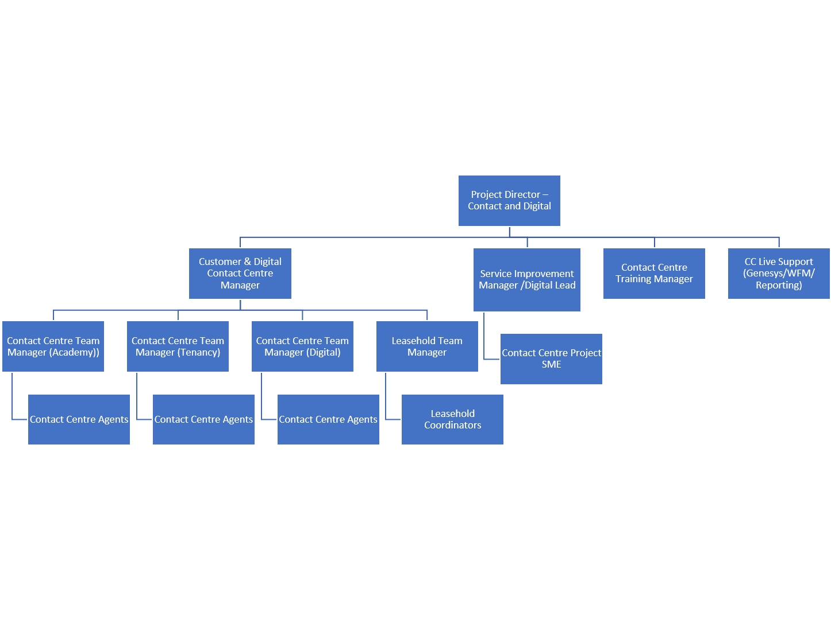

Key internal contacts
- All Operations Teams including all teams that make up the Customer Directorate plus Repairs, Joint Ventures, I.T., L&D, Communications and Support Services
- EMT, Board, Committees
- Senior Management Team – for strategic planning and updates.
- Colleagues and Peers – for collaboration on projects and sharing best practices.
- People Services – for recruitment, staff development, and employee relations.
- Financial Services – for budget management and financial reporting.
- Health and Safety – for ensuring workplace compliance and safety measures.
- IT Department – for technology support and systems updates.
- Procurement – for managing contracts and supplier relations.
- Communications or Marketing Team – for internal and external messaging.

Key external contacts
- Customers – for the purpose of delivery services
- Service providers – including management of Out of Hours Service Contract

Operating environment/dimensions
Customer base: All customers for the purpose of customer contact

Job persona: Hybrid (with office attendance at least 3 times a week – Ealing, W5) and other office attendance when required

Delegated authority limit: Ordering limit: £50,000 Authorisation Limit: £50,000

DBS level: Basic

KPIs:
82% First Contact Resolution
20% digital usage
Grade of Service -
- Calls – Average speed of answer under 4 minutes
- Live Chats - Average speed of answer under 2 minutes
- Emails – responded to in person within 5 working days
- Web contact – responded to in person within 2 working days.
- Customer Satisfaction – 75% of residents scoring 3,4 or 5 for overall satisfaction

Mandatory training: Complaint Champions (Stage 2), Domestic Abuse (Level 2), Safeguarding for Frontline Staff (Level 2), Safeguarding for People Managers (Level 3)

Qualifications and training | Essential  (Y) | Desirable (Y)
Educated to GCSE level or equivalent in Maths and English (Grades A*- C) | Y
Educated to degree level |  | Y
Knowledge and skills
A minimum of 2 years experience in a leadership role in a Housing Environment | Y
A minimum 2 years experience in a leadership role in a Contact Centre Environment | Y
Extensive knowledge of Housing/Tenancy related issues | Y
A formally recognised Housing Qualification |  | Y
Understanding and Experience of Consumer Standards relating to Housing Providers |  | Y
Leadership & Coaching – Ability to lead, mentor, and develop Contact Centre Team Managers to optimize team performance | Y
Customer-Centric Approach and Customer Service Expertise – A deep understanding of customer service principles and best practice, ensuring high-quality interactions and first-contact resolution. | Y
Communication & Collaboration – Working with multiple teams (Quality Assurance, Recruitment, Business Improvement) to streamline processes and improve service delivery | Y
Analytical & Problem-Solving Skills – Capability to analyse KPIs, identify performance gaps, and implement solutions. | Y
Stakeholder Engagement - Strong communication, negotiation, and collaboration skills to engage with multiple stakeholders across the organisation and externally. | Y
High proficiency in all Microsoft Office Programmes (Word, Excel, Powerpoint) | Y
Risk and Compliance Management - Experience of risk management, and ensuring compliance with regulations, particularly related to contact and complaint services | Y
Knowledge and clear understanding of Contact Centre systems (CSAAS) and associated telephony systems | Y
Knowledge and clear understanding of Genesys (CSAAS) system and associated elements |  | Y
Proficient in Microsoft Dynamics CRM system |  | Y
Knowledge of A2Dominion’s Processes and Procedures |  | Y
Knowledge of Industry Trends & Innovations – Keeping up with emerging technologies such as AI, automation, and customer engagement tools. | Y
Knowledge of Customer Contact KPIs & Metrics – Understanding key performance indicators and how to measure success. | Y
Knowledge of Quality Assurance Standards – Ensuring compliance with external standards and best practices. | Y
Knowledge of Workforce Planning & Recruitment – Ensuring appropriate staffing levels while staying within budget. | Y
Behaviours for success
Influential
- Inspiring Leadership – Motivates and empowers teams, fostering a culture of high performance and accountability.
- Stakeholder Management – Builds strong relationships with internal and external stakeholders to drive improvements and innovation.
- Persuasive Communication – Clearly articulates strategies and ideas, influencing decisions to enhance customer service and operational excellence.
Future focused
- Continuous Improvement Mindset – Proactively seeks opportunities to enhance processes, customer experiences, and digital transformation.
- Strategic Thinking – Plans ahead to anticipate challenges and align Contact Centre operations with long-term business goals.
- Innovation & Adaptability – Encourages creativity and embraces emerging technologies to stay ahead in a dynamic environment.
Engaging
- Team Development & Coaching – Actively supports and mentors team managers, promoting growth and confidence.
- Collaborative Working – Creates partnerships across departments, ensuring seamless service delivery and problem resolution.
- Customer-Centric Approach – Prioritises customer needs, enhancing engagement and fostering trust through exceptional service.
Resilient
- Decision-Making Under Pressure – Handles challenges with confidence, maintaining focus and effectiveness in demanding situations.
- Emotional Intelligence – Manages emotions and relationships effectively, ensuring a positive work environment.
- Ownership & Accountability – Takes responsibility for outcomes and learns from setbacks to drive continuous improvement.

Performance focused
- Results-Driven Mentality – Sets ambitious goals and drives the team towards achieving high performance.
- Data-Informed Decision Making – Uses analytics and KPIs to identify trends, optimise operations, and improve efficiency.
- Operational Excellence – Ensures processes are streamlined, cost-effective, and aligned with business objectives.

This job description outlines the main responsibilities and requirements of the job. Colleagues are expected to comply with reasonable management requests to carry out additional or alternative duties.

